CF-RU6403 Demo Software User's Guide V2.2
1. Parameter interface operation 1
1.1 Open Port 1
1.2 Parameter Setting: 2
2. Set work mode parameter 4
2.1 Real-time-inventory Setting: 4
3. The Necessary Knowledge 5
3.1 EPCC1G2 tag memory 5
3.2 18000-6B tag 5
3.3 Data display (tag ID, passwords, memory data is display in 16 hexadecimal) 5
4. EPCC1-G2 Test operation 6
4.1 Query Tag EPC(The operation needing to choose the tag all need to query tag first) 6
4.2 Query Tag TID 6
4.3 Read Data, Write Data, Block Erase 6
4.4Revise the password 9
4.5 Write EPC (Needn’t query tag) 10
4.6 Set the state of read and write protection 10
4.7 Read Protection 11
4.8 EAS Alarm 12
4.9 Kill Tag（Permanently Kill） 13
4.10 Mask conditions 13
5. Mix-Test Operation 14
6. Buffer Operation 15
7. 18000-6B Test Interface Operation 15
7.1 Query Tag 15
7.2 Read and Write Data Block / Permanently Write Protect Block of Byte 18
8. Frequency Analysis Operation 19
9. Config TCPIP 19
9.1Web config 19

1. Parameter interface operation

1.1 Open Port
Before open com port, please make controller properly connected with the host using the communication cable provided and then turn on the power.
（1）Auto Open Comport:
Value 255(0xFF) is broadcasting address. All controllers will respond the order with a broadcasting address.
Other value (0x00~0xFE) is controller address. Only will the controller conforming to the address respond the operation.
Click 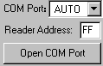，If reader connect the computer's COM1 ~ COM9, we can see the port display in the place. the demonstration software to 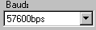by connecting the port and written communication, the connection to the port to have a beginning, such as ：
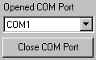else 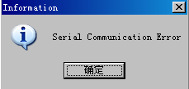

（2）Open Designated Comport:
Click 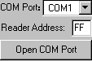,the Baud will Auto Select From 115200bps, 57600bps, 38400bps,19200bps，9600bps,if success
else
(3) Open USB port:
If the reader is set to usb communication, then we select “USB” 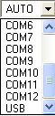,and click .
(4)Open TCP/IP
Select ,and input reader ip and port: 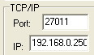,click .

1.2 Parameter Setting:
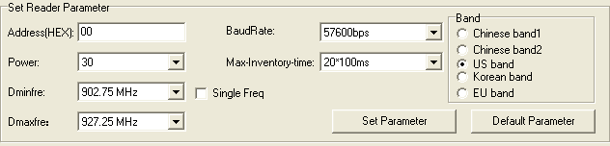
（1） the new reader address to set. This address can't be 0xFF. If set 0xFF, reader will return error information.
（2）set and save power configuration.
（3）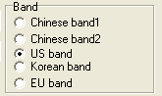select the reader’s band, different band, the frequency is different.
（4） Set reader working Min Frequency and Max Frequency. In different places, the radio requires the rule to be different. Users can follow the local situation and choose to read more sensitive frequency range of the card. In single frequency point operation, only need to set two frequencies to the same value. In frequency hopping operation, only need to set two frequencies to the different value.
（5） demo software start run, default use the baud rate 57600 to open COM port, reader power on, reader baud rate default is 57600. After change the baud rate, reader use the new baud rate until power off. Close port and open port, the baud rate no change. The demo software will use the new baud rate, until close the demo software.
（6） set the inventory scan max response time of reader. If demo software sends the inventory order, it will wait 30*10ms for reader response and exits.
（7）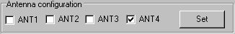，Select antenna 4，click ，At this time, antenna 4 in working status, can also select multiple antenna working together.
(8) 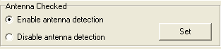,this function is used to set weather detect antenna before query tag.
（9）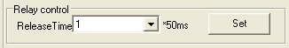，select release time
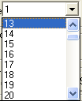，click can set release time.

（10）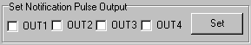，select output port，click ，Can install require notification output port.
（11）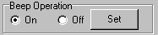，Choose buzzer switch state, click Settings button to complete the operation, buzzer open, when reading or writing to label operation is successful have prompt.
(12) 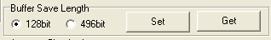Set or get saved EPC/TID length in buffer.
(13) 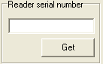 click ‘Get’ button can get reader’s serial number.

2. Set work mode parameter

2.1 Real-time-inventory Setting:
(1) 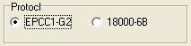select read tag type on real-time- inventory mode.
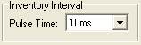select read pulse time on real-time- inventory mode.
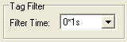Select tag filter time, if select 0 is not filter.
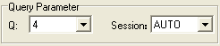Select Q and Session on real-time-query inventory.
When Session is AUTO, only effective with EPC query.
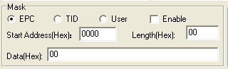set mask conditions on real-time- inventory mode, if you want it effective, you should check .
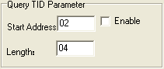 Set query TID parameter on real-time-query inventory, if you want it effective, you should check .
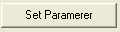set parameter with you select condition, get reader parameter on real-time-inventory inventory.

(2) 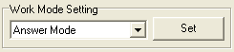Set reader work mode, if it set to
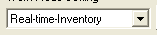 , we can get data from port by button
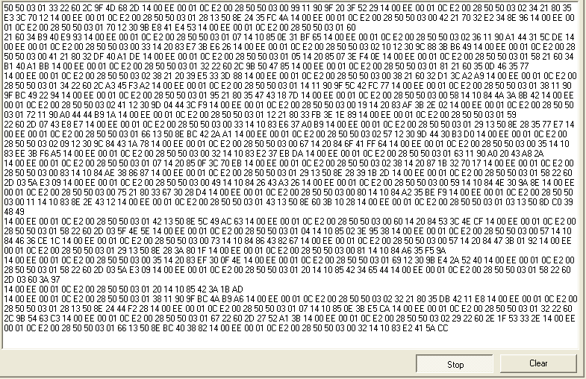

3. The Necessary Knowledge

3.1 EPCC1G2 tag memory
Tag memory divided into four storage areas, each storage area can be made up of one or more memory words. The four storage areas:
EPC areas (EPC): Store the area of EPC number, this module stipulates it can store 15 word EPC number. Can read and can write.
TID areas (TID): Store ID number established by the tag production firm. There are 4 words and 8 words two kinds of ID numbers at present. Can read and not can write.
User areas (User): This area of different manufacturers is different. There is no user area in G2 tag of Inpinj Company. There are 28 words in Philips Company. Can read and can write.
Password areas (Password): The first two words is kill password, the last two words is access password. Can read and can write.
Can write protect in four storage areas. It means this area is never writeable or not writeable under the non-safe state; only password area can set unreadable.

3.2 18000-6B tag
6B tag has a memory space, the minimum 8 bytes (byte 0- 7) is UID of the tag, and can't be rewritten. Following byte all can be rewritten, can be locked too, but once locking, can't rewrite again, can't unblock either.

3.3 Data display (tag ID, passwords, memory data is display in 16 hexadecimal)
Display in Hex, then 11 is first byte, 22 is second byte, and 1122 is first word.
Total 8 bytes, in other words, total 4 words.

4. EPCC1-G2 Test operation

4.1 Query Tag EPC(The operation needing to choose the tag all need to query tag first)
（1）Every 50ms issued a command checks. Select ,,if Session select AUTO, only effective by query EPC.
（2）
can see

4.2 Query Tag TID
（1）Select
（2）Input query tag TID conditions

（3）
can see

4.3 Read Data, Write Data, Block Erase
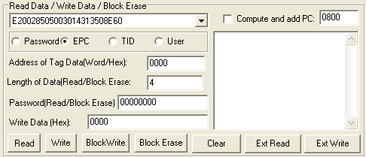

(1) Read data operation
<1> Choose tag
<2> Choose memory
<3> Write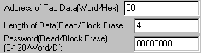
Start address: 0x00 stand in start to read data from first word in the designated storage area, 0x01 stand in start to read data from second word in the designated storage area, and so on.
Read the length: Number of the word to be read. It read 120 words at most. Can not set 0 or 120, otherwise, return the parameter error information.
Access password: From left to right it is the former high-word, low word in the access password. If operation don’t need access password, it can be the arbitrary value, but can't lack.
<4> Clickcan see
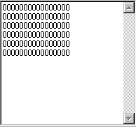
(2) Write data operation
<1> Choose tag
<2> Choose memory
<3> Write（EPC memory Address of tag is 2）
Start address: 0x00, the first word of data (from left) is written in address 0x00 of the designated storage area, and so on.
<4> Clickcan see
Note: write data can be used to change the EPC number (the method is as follows)
<1> Choose tag
<2> Choose memory ,and
select
<3> Write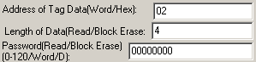（EPC memory Address of tag is 2）
<4> Clickcan see
Then query tag EPC,can see
(3) Block Erase Operation (write 0 to the designated data )
<1> Choose tag
<2> Choose memory
<3> Write
Start address: 0x00 stand in start to erase data from first word in the designated storage area, 0x01 stand in start to erase data from second word in the designated storage area, and so on.
The difference from write operation: Needn't fill in the data.
<4> Clickcan see
(4) Write block operation
<1> Choose tag
<2> Choose memory
<3> Write（EPC memory Address of tag is 2）
Start address: 0x00, the first word of data (from left) is written in address 0x00 of the designated storage area, and so on.
<4> Clickcan see

4.4Revise the password
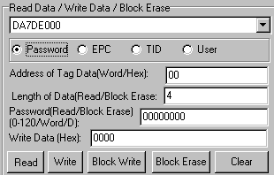
(1) Choose tag
(2) Choose memory
(3) Write access password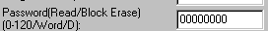
Access password: From left to right it is the former high-word, low word in the access password. If operation don’t need access password, it can be the arbitrary value, but can't lack.
(4) Revise the access password 12345678: Write
Click
- Revise the kill password 12345678: Write
Click
(6) If succeed, we can see

4.5 Write EPC (Needn’t query tag)
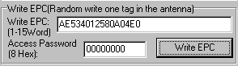
(1) Write access password (If EPC area of the tag has not set password protection, we can write 8 data arbitrarily)
(2) Write EPC.
(3) Click . (Random write one tag in the effective range of antenna)
When there are many or EPC pieces of tag in the effective range of antenna, and the access password of one tag is the same as you entered, or EPC area of tag set no password protection, click at a time, random write EPC number of one tag in the effective range of antenna.

4.6 Set the state of read and write protection
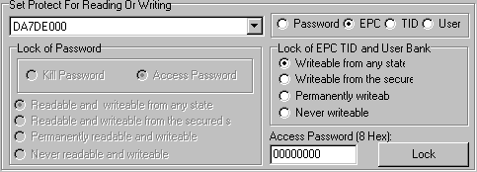
(1) Choose tag
(2) Choose memory
(3) Choose protection type
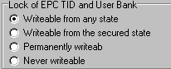

(4) Write access password:
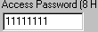Any storage area in no password protection status still must write the correct access password.(password can not be zero).

4.7 Read Protection
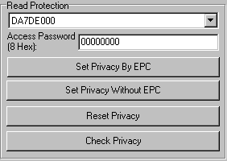
(1) Set Single Tag Read Protection
<1> Choose tag
<2> Write tag access password
<3> Click
According to EPC number of the tag, setting read protection, make tag unable to be read and written by any order, even if query the tag, it is unable to get EPC number of the tag. Only NXP UCODE EPC G2X tags valid.

(2) Set Single Tag Read Protection without EPC
<1> Write tag access password
<2> Click can set tag read protection in the effective range of antenna
The difference from : When there are several tag in the effective range of antenna, reader don’t know the tag which the order operate.
If operate several tags, then the access password of the tag had better be the same. Only NXP UCODE EPC G2X tags valid.
(3) Reset Single Tag Read Protection without EPC
<1> Write access password
<2> Click
Use for reset the tag read protection.
Only put a tag in the effective range of antenna. Only NXP UCODE EPC G2X tags valid.
Comments: If tag does not support the read protection setting, it must be unprotected.
(4) Detect Single Tag Read Protection without EPC
<1> Click
Can't detect tag whether it support read protection order, can only detect single tag whether it is protected. If tag does not support the read protection setting, it must be unprotected.
Make sure that there is single tag in the effective range of antenna. Only NXP UCODE EPC G2X tags valid.

4.8 EAS Alarm
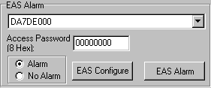

(1) Alarm setting
<1> Choose tag
<2> Write access password
<3> Choose alarm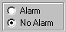
Set or reset the EAS status bit of tag. Only NXP UCODE EPC G2X tags valid.
(2) Check alarm without EPC and access password
<1> Click check alarm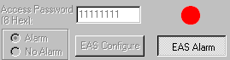
Check the EAS alarm of tag. Only NXP UCODE EPC G2X tags valid.
<2> EAS alarm:
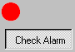
No EAS alarm:

4.9 Kill Tag（Permanently Kill）
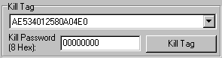
(1) Choose tag
(2) Write 
Kill password can not be the whole 0. Otherwise, the tag can not be killed, and the tag return response with parameter error.

4.10 Mask conditions
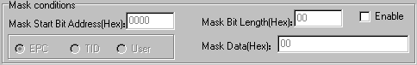
（1）check enable
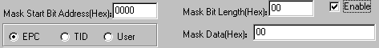
Only check enable can do mask operation。
For example, EPC mask：
Choose EPC area：
Only the first byte of tag’s EPC is DA could response.
For example, TID mask：
<1>Query TID 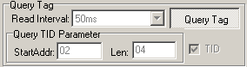
Can see TID
<Mask condition>
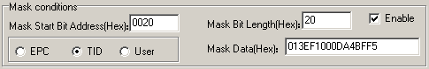
For example change EPC :
<2> select
and
<3> Write（EPC memory Address of tag Is 2）
<4> Clickcan see
Then query tag EPC,can see

5. Mix-Test Operation
(1) Select antenna, Q value and session for example:
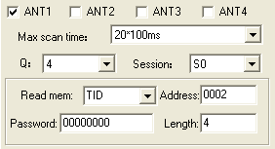.it means read tag epc and tid, tid is form 2 ,read 4 words.
(2)Click 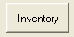,if there are tag, can see:
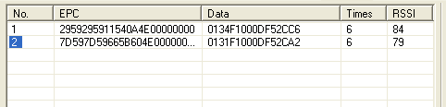

6. Buffer Operation
(1) Select EPC/TID query. For example: EPC
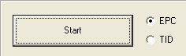
This demo is used Q=4,S=auto, if there are some tag
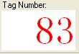
(2)  is used to read tag in the buffer, if there are tag
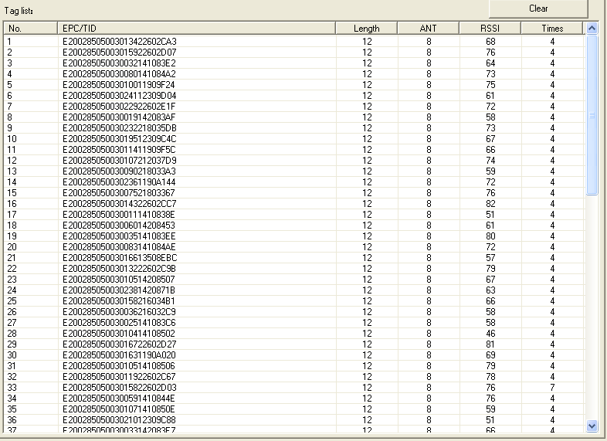
(3)  is used to clear tag information in the buffer.
(4) is used to read out tag and clear tag in the buffer.
(5) is used to get tag number in the buffer.

7. 18000-6B Test Interface Operation

7.1 Query Tag
(1) send a inventory command every 50ms.
(2) 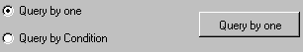
Only query the single tag. If many tags are in the effective range of antenna at the same time, it may be unable to query the tag.

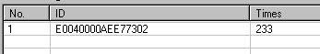
(3) 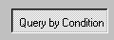
<1> Unequal Condition:
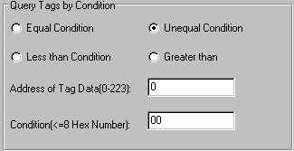
Note:
The 8 bytes of 6B tag number write in the 0~7 which in the address of tag data (0- 233)
Figure, query condition begin to compare from the tag data address 0. The comparative content is 22.
Click
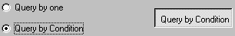
See
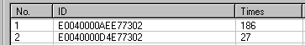
Figure, from the tag number we can see the addresses 0 of tag data: 00, 00, 11, 11.
Unequal condition 22, therefore, the four tags are read.
<2> Equal Condition:
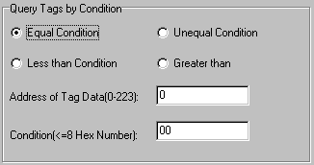
Note:
The 8 bytes of 6B tag number write in the 0~7 which in the address of tag data (0- 233)
Figure, query condition begin to compare from the tag data address 0. The comparative content is 00.
Click
See
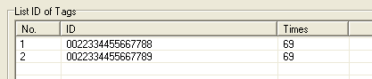
Figure, from the tag number we can see the addresses 0 of tag data: 00, 00.
Equal condition 00, therefore, the two tags are read.
<3> Greater than
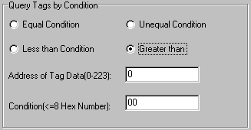
Note:
The 8 bytes of 6B tag number write in the 0~7 which in the address of tag data (0- 233)
Figure, query condition begin to compare from the tag data address 0. The comparative content is 00.
Click
See
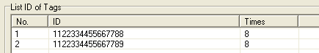
Figure, from the tag number we can see the addresses 0 of tag data: 11, 11.
Great than 00, therefore, the two tags are read.

7.2 Read and Write Data Block / Permanently Write Protect Block of Byte
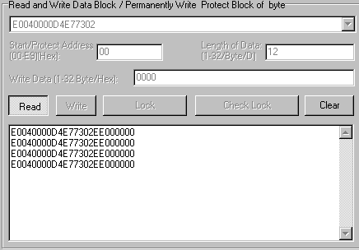
(1)
(2) Read data:
Start address: 0x00 stand in start to read data from first word in the designated storage area, 0x01 stand in start to read data from second word in the designated storage area, and so on. Range is 8~223. Beyond this range, reader will return parameter error.
Read length: pointed to the number of bytes to read. Range is 1~32. If Start address + Read length greater than 224, or Read length greater than 32 or is zero, reader will return parameter error information. The high bytes of Read length write in the low address in tag.
(3) Write data:
Write data: Range is 1~32. If Start address + Write length greater than 224, or Write length greater than 32 or is zero, reader will return parameter error information. The high bytes of Read length write in the low address in tag.
(4) Permanently Write Protect: lock the designated byte.
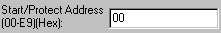
(5) Check Protect: check whether the designated byte is locked.
(6) If succeed, we can see:

8. Frequency Analysis Operation
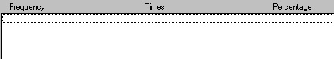
Click,can see
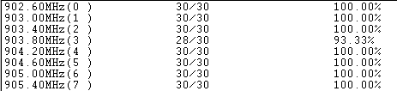
The larger of the percentage ,the better of the results.

9. Config TCPIP

9.1Web config
1.Select，click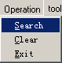Search.
If device connected.
Select the device
2.Select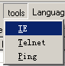,default user name and password are admin.
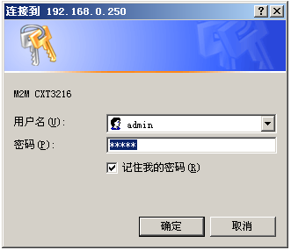Login.
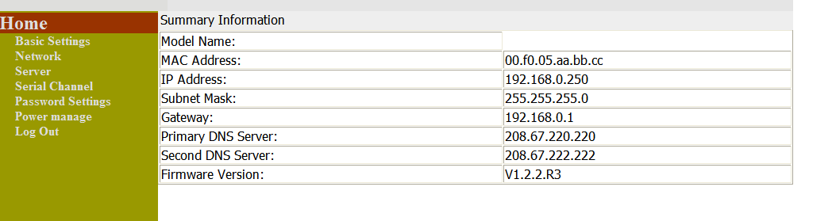
（1）Select，default:
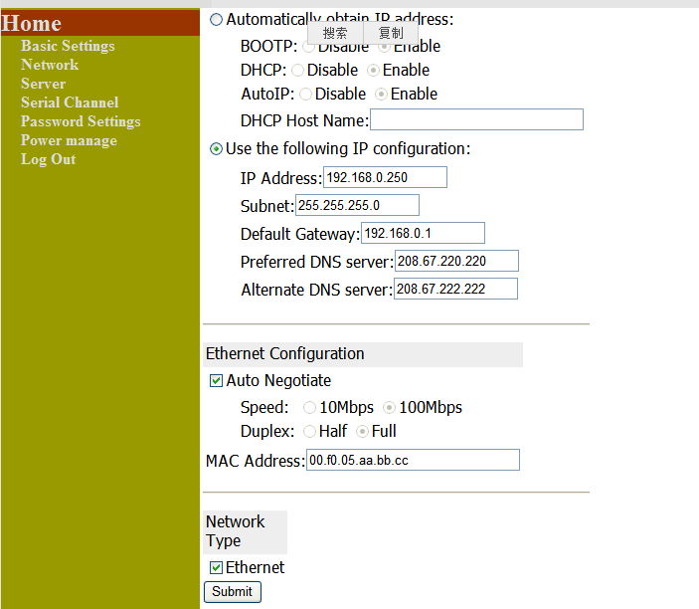
Finished click.
（2）Select,
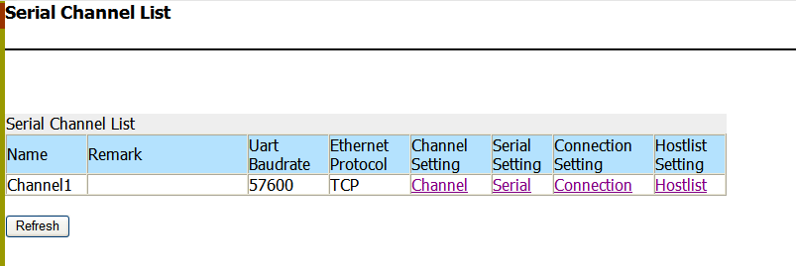
Click 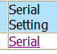
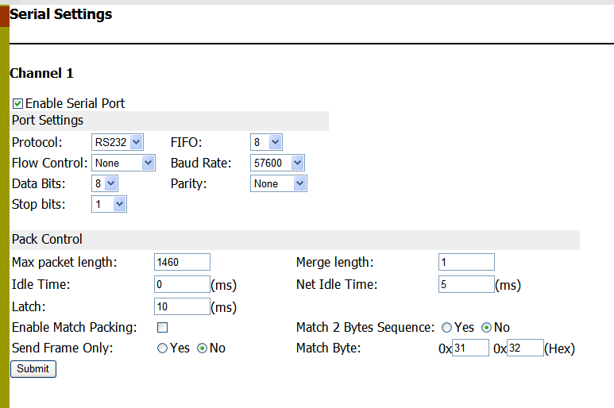
Finished .click
Click 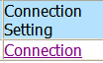

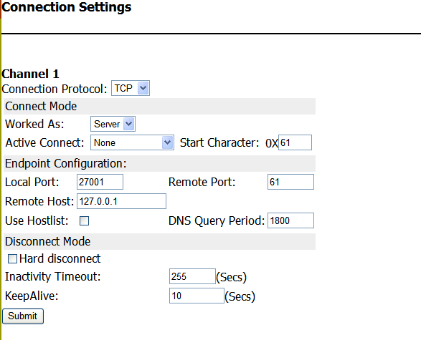
Finished click .
（4）The end select.
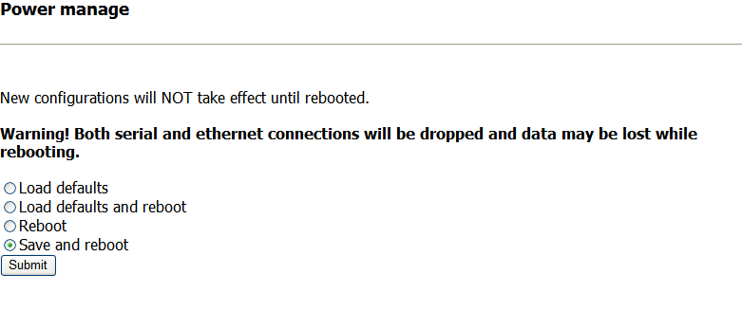Click，Restart your device.

